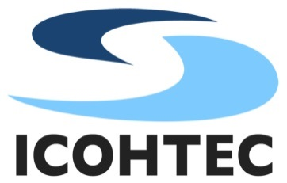

International Committee for the History of Technology

BRASOV SYMPOSIUM
ICOHTEC TRAVEL GRANTS
THE DEADLINE IS 24 MARCH 2014

Guidelines

The ICOHTEC Board will make available a limited number of grants for graduates, post-graduates and young researchers who are giving papers the 2014 ICOHTEC Symposium Technology in Times of Transition in Brasov, Romania, 29 July – 2 August 2014. Special preference will be given to students and young researchers from developing countries as well as Eastern and Central European countries in transition who are not able to receive sufficient financial support from their home countries or sponsors in other countries.

These travel grants are not intended to provide the full costs associated with attending the symposium; they are meant as an encouragement, not a full subsidy.

Eligibility: ICOHTEC Travel Grants will be awarded to students or young researchers, travel costs and accommodation costs of whom have not been covered from other sources.

The Travel Grant of 350 euro is to be used to cover bus/train/flight tickets, lodging and/or registration fee. Reimbursement will be made after presenting paper and proving the student’s or young researcher status by an appropriate document (Student’s ID or supervisor’s/professor’s letter).

Application forms should be sent to the chair of the Travel Grant Committee as email attachments or by ordinary mail. Applications for support must include personal contact information, an estimate on travel, registration and accommodation costs, title of the paper to be presented and a short CV. An application form may be downloaded from the ICOHTEC web site at:
www.icohtec.org/annual-meeting-2014-travel-grant.html

Deadline: Applications with appendices should be submitted by Monday 24 March 2014. Submissions via email are requested and preferred. Grants will be announced by 24 April 2014.

Slawomir Lotysz
Secretary General & Chair of the Travel Grant Committee
Institute of Civil Engineering
University of Zielona Gora
ul. prof. Z. Szafrana 1
65-516 Zielona Góra
POLAND
Tel. +48 605 224 326
Email: s.lotysz@gmail.com
ICOHTEC’s Website: www.icohtec.org

